
Update date, xx xxxx

Visa Debit Card Dispute Management
PROCESS

October 1, 2026

Document Tracking and Control Table

Policy Owner | TBC
Approval Date | TBC
Version | TBC
Access Level | TBC
Policy Author | TBC
Subject Matter Expert(s) | TBC
Last Full Review Date | TBC
Update Date (changes were made but a full review was not necessarily conducted) | TBC
Review Frequency Requirement | TBC
Changes made | TBC
Stakeholders Impacted | TBC

Purpose
The Visa Debit Card Dispute Management Procedure guides the Growth Team, Payment Services Team, and Fraud Prevention Department in managing member-initiated Visa Debit Card disputes. It sets out a consistent approach for receiving and triaging dispute claims, gathering and assessing supporting documentation, issuing provisional credit, submitting and managing disputes through Central 1 and the Visa network, and resolving disputes and recovering funds where applicable. It also covers the roles and systems involved, the process flows, and the detailed procedures across the dispute management lifecycle.

Scope
This procedure applies to all team members involved in the intake, triage, investigation, submission, and resolution of member-initiated Visa Debit Card disputes, received through the following channels:
- Branch: occurs when a member visits Beem’s branch to dispute a Visa Debit Card transaction.
- Contact Centre: occurs when a member contacts Beem’s Growth Team by phone to dispute a Visa Debit Card transaction.
This procedure covers the five stages of the dispute management lifecycle:
Stage 1. Dispute Intake
Stage 2A. Provisional Credit Issuance
Stage 2B. Dispute Triage
Stage 3. Case Preparation & Document Assessment
Stage 4. Network Submission & Response
Stage 5. Resolution & Recovery

Roles and Systems
The following roles and systems support various activities within the Visa Debit Card Dispute Management Procedure.
Role / System | Responsibility
Growth Team | Front-line contact centre and branch staff who maintain contact with members, receive the member's dispute claim, verify the cardholder and impacted transaction(s), records dispute details. Where required, they perform initial account security actions, such as blocking and reissuing the card.
Payment Services Team | Investigates and manages non-fraud (recognized/authorized transactions) disputes referred by the Growth Team, prepares case documentation, submits eligible disputes to Central 1, manages provisional credit throughout the dispute lifecycle, and handles dispute outcomes (reimbursement / recoveries).
Fraud Prevention Department | Fraud Management / Fraud Specialists provide centralized expertise and coordination to support consistent fraud detection, escalation, investigation, response, recovery, and reporting practices across the organization. They are responsible for leading or coordinating fraud investigations and case management activities, supporting appropriate evidence and documentation practices, and enabling effective cross-functional coordination and governance visibility for significant fraud risks, trends, and incidents.  Key responsibilities may include:  - conducting or coordinating fraud investigations and case management activities,  - maintaining case documentation and supporting appropriate evidence handling practices,  - coordinating escalation, response, containment, and recovery activities with relevant operational and support functions,  - supporting reimbursement and remediation activities in accordance with established guidelines and approvals,  - monitoring fraud trends, emerging risks, and typologies to inform detection and control improvement opportunities,  - supporting fraud reporting, analytics, and governance visibility into material incidents and trends,  - providing operational guidance and input into training and awareness materials,  - coordinating with external parties (e.g., law enforcement, insurers, payment networks) where appropriate.
Central 1 | Beem's financial services partner that receives completed dispute submissions and routes them, via Prairie Payments Joint Venture (PPJV), to the FIS Everlink Settlement team for submission to Visa Resolve Online (VROL) on Beem's behalf.
FIS Everlink (Everlink) | Beem's Visa Debit program processor. Submits dispute requests to Visa on Beem's behalf via VROL, and manages the pre-arbitration and arbitration cycle in accordance with Visa Rules and pre-defined processes and timelines.
CRM (Dynamics 365) | System of record used to create and track dispute cases and trigger both the ATM/POS trace (non-fraud) and Fraud Intake Form (FIF) (fraud) workflows.
DNA | Beem's core banking system used to review member and account information and apply card or account restrictions.
Mastek | Reconciliation and transaction data solution used to access Everlink transaction information and identify the network on which a disputed transaction was processed.

Stage 1: Dispute Intake Process (Growth)

4.1 Process Flow
The visual overview below provides the end-to-end process for a member contacting the contact centre or a branch to initiate a Visa Debit Card dispute. This stage is owned by the Growth Team.
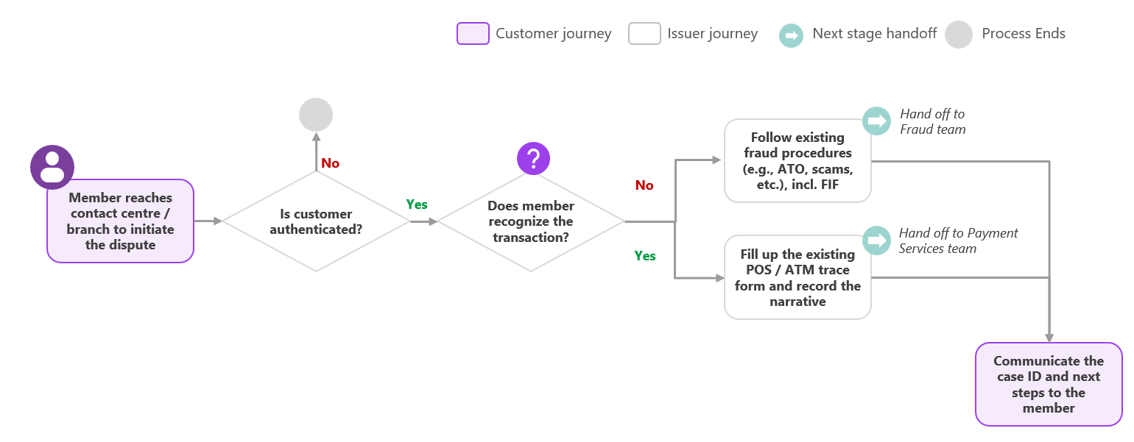

4.2 Procedure
The following procedure provides a step-by-step outline of the activities performed by Growth as part of dispute intake.

4.2.1 Authenticate the Member
Upon a member contacting the Contact Centre or a Branch to dispute a Visa Debit Card transaction, the Growth Team member should:
Verify that the individual is the cardholder, in line with Beem’s existing member authentication procedures — please refer to the Identity Verification Guidelines<link>. If the member cannot be authenticated, do not proceed with intake.

4.2.2 Locate the Transaction
The Growth Team member should:
- Locate the transaction the member is disputing in DNA, using the date, amount, and / or merchant name provided by the member.
  - If located: proceed to Step 2.
  - If it cannot be located: ask the member to reconfirm the date, amount, and merchant name, and search again. If the transaction still cannot be located, advise the member that Beem has no record of this transaction and a dispute cannot be initiated at this time.
- Confirm transaction posting in DNA – has the transaction posted to the member's account as is visible in DNA?
  - If not yet posted: advise the member that the transaction is currently pending and that a dispute can be initiated once the final transaction has posted to the account. Reassure the member that they may still dispute the transaction after it posts and record a note / message in DNA documenting the member's inquiry.
  - If posted: proceed to Section 4.2.3 — Create the CRM Case.

4.2.3 Create the CRM Case
Open a new CRM Case and populate the following:
- Case Details (auto-populated): unique case ID, case creation date, current status, and owner.
- Member Details: member full name (search), member email (auto-populated based on name), member phone number (auto-populated based on name).
- Transaction Details (search for same transaction as Section 4.2.2): date, merchant, and amount.
- Determine recognition of transaction: Determine whether the transaction is recognized or unrecognized. Below are guidance questions to help inform this determination:
  - “Did you authorize this transaction? Do you recognize the merchant name, even if you don’t recall the specific purchase?”
    - e.g., “No, I’ve never heard of this merchant” → potentially indicates fraud.
    - e.g., “Yes, I recognize the merchant and I made that transaction” → potentially indicates non-fraud.
  - “Could this charge be part of a recurring subscription or membership you may have forgotten about?”
    - e.g., “Oh, I think I signed up for a trial a few months ago” → potentially indicates non-fraud.
    - e.g., “No, I don’t have any subscriptions with this merchant” → potentially indicates fraud.
  - “Does the amount and date match what you recall for that day? Sometimes merchants bill under a different name than their storefront (e.g., a parent company).”
    - e.g., “Now that you mention it, that transaction does ring a bell” → potentially indicates non-fraud.
    - e.g., “No, that transaction means nothing to me” → potentially indicates fraud.
Based on the member’s responses, the Growth Team member should manually select whether the transaction is “Recognized / Non-fraud” or “Unrecognized / Fraud” in CRM - if the member remains confident or adamant that they did not make the transaction, select “Unrecognized / Fraud”. The CRM then automatically surfaces the applicable form within the case:
- Recognized / Non-fraud: the ATM/POS Trace Request form appears. Proceed to Section 4.2.4 — ATM/POS Trace Request.
- Unrecognized / Fraud: the Fraud Intake Form appears. Proceed to Section 4.2.5 — Fraud Intake Form.

4.2.4 ATM/POS Trace Request (Non-fraud)
The Growth Team member should then populate the remaining ATM/POS Trace Request fields within the case, including a note with the following details to help with the Payment Services Team investigation:
- Date/time of conversation with the member
- Method of instruction (branch / phone)
- Any other relevant details the member provided
- Dispute narrative – The following guidance questions may be used:
- Reason for the dispute: "Were the goods or services not received or not as described, or were you charged twice or the wrong amount?"
- Prior merchant contact: "Have you contacted the merchant to try to resolve the issue? If so, what was their response?"
    - E.g., "No, I haven't reached out to them yet." → recommend that the member try contacting the merchant first, as it may resolve the issue faster — however this is a recommendation, not a requirement.

4.2.5 Fraud Intake Form (Fraud)
Once the transaction is determined to be unrecognized, the Growth Team member should determine whether the member is disputing a Visa Debit Card transaction. Below is a guidance question is to help inform this determination if the cardholder is unsure:
- “Do you have a Visa Debit card, or were issued a card within the last 30 days?”
  - e.g., “No, I’ve had the same card for years — not that new Visa one.” → potentially indicates member does not hold Visa Debit Card.
  - e.g., “Yeah, I got the new Visa card a couple months ago.” → potentially indicates member does holds Visa Debit Card.
Based on the member’s response, determine whether the member is disputing a Visa Debit Card:
- If the member is disputing a Visa Debit Card transaction: Growth Team member should follow the Visa Debit Card Fraud Process <link>.
- If the member is NOT disputing a Visa Debit Card transaction: The Growth Team member should follow the applicable existing fraud processes (e.g., Account Takeover Fraud Process, Member Card Fraud Process, etc.).
The Growth Team member should also complete the Fraud Intake Form (FIF) – see the Fraud Intake Form Procedures<link>.

Stage 2A: Provisional Credit Issuance (Payment Services Team)

5.1 Process Flow
[Process flow diagram to be added]

5.2 Procedure
This stage is owned by the Payment Services Team and occurs immediately after Stage 1: Dispute Intake, for both Fraud and Non-Fraud cases.

5.2.1 Issue Provisional Credit
Upon receipt of a newly created case, the Payment Services Team should verify the disputed amount, then issue a temporary provisional credit for that amount to the member’s account. Document in the CRM case notes that the provisional credit was issued, then set the CRM case status to “Ready for Triage”, which routes the case to the Fraud Prevention Department or Payment Services Team for Section 6 – Stage 2B: Dispute Triage. [feedback: can you make this more clear steps, I’m not a huge fan of how everything is merged together into one paragraph.]

Stage 2B: Dispute Triage (Payment Services Team / Fraud Prevention Department)

6.1 Process Flow
The following procedure provides a step-by-step outline of the activities performed by the assigned Payment Services or Fraud agent as part of dispute triage.
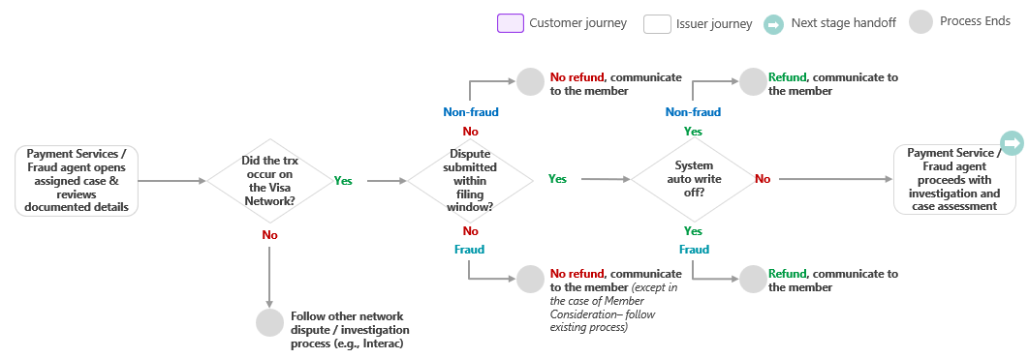

6.2 Procedure

6.2.1 Confirm Disputed Transaction Network
Upon opening the assigned case, the Payment Services Team member / Fraud Specialist should review the documented details received from the CRM case and:
- Confirm whether the disputed transaction occurred on the Visa Network by verifying the transaction network code in Mastek [TBC — Fraud Prevention Team to be granted access]
  - If the transaction did not occur on the Visa Network: follow the applicable other network dispute / investigation process (e.g., Interac).
  - If the transaction occurred on the Visa Network: proceed to Section 6.2.2 – Assess Filing Window and Auto Write-off.

6.2.2 Assess Filing Window and Auto Write-Off
- Assess filing window: the assigned Payment Services Team member / Fraud Specialist should assess whether the dispute was submitted within the filing window — members must dispute a transaction no later 60 days from the transaction date, as per cardholder agreement.
  - If the dispute was submitted within the filing window: proceed to Step 2.
  - If the dispute was not submitted within the filing window: the assigned Payment Services Team member / Fraud Specialist should then: [feedback: should be ‘no refund. The assigned Payment Services Team member / Fraud Specialist should then:’]
- Document the rationale in the CRM case notes. [feedback: should be ‘Document the rationale for the refund decision in the CRM case notes then proceed to Step 1b’]
- Set the CRM case status to “Reverse Provisional Credit”, which routes the case to the Payment Services Team for Section 9 – Stage 5: Resolution & Recovery.
- Note: (Fraud Prevention Department only) in the case of Member Consideration — please refer to the Fraud Reimbursement Guidelines <link>.
- Assess auto write-off: the assigned Payment Services Team member / Fraud Specialist should assess whether the dispute qualifies for a system auto write-off — the auto write-off threshold is $150 for fraudulent and non-fraud disputes [TBC - $150 for non-fraud disputes]; the Payment Services Team member / Fraud Specialist should then determine:
  - If the dispute amount is equal or above the applicable threshold: [feedback: can you also say to set the case status to ‘Under Investigation’ then proceed] proceed to Section 7 – Stage 3: Case Preparation & Document Assessment.
  - If the dispute amount is below the applicable threshold: the assigned Payment Services Team member / Fraud Specialist should then: [feedback: should be ‘Document the rationale for the refund decision in the CRM case notes then proceed to Step 1b’]
- Document the rationale in the CRM case notes. [feedback: should be ‘Document the rationale for the refund decision in the CRM case notes then proceed to Step 1b’]
- Set the CRM case status to “Finalize Provisional Credit”, which routes the case to the Payment Services Team for Section 9 – Stage 5: Resolution & Recovery.

Stage 3: Case Preparation & Document Assessment (Payment Services / Fraud)

7.1 Process Flow
The visual overview below provides the end-to-end process for case preparation and document assessment. This stage is owned by the Payment Services Team and Fraud Prevention Department.
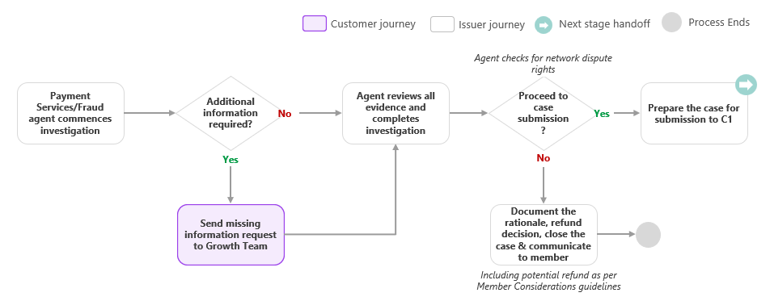

7.2 Procedure
The following procedure provides a step-by-step outline of the activities performed by the assigned Payment Services Team member or Fraud Specialist as part of case preparation and document assessment.

7.2.1 Commence Investigation (Fraud and Payment Services Team)
The assigned Payment Services Team member / Fraud Specialist commences investigation of the case:
- Fraud Prevention Department: refer to the Visa Debit Card Fraud Investigation Process <link>. Once investigation is complete and decision is reached, if applicable proceed to Section 7.2.4 — Assess Network Dispute Rights.
- Payment Services Team: proceed to Section 7.2.2 — Review Referral and Available Information.

7.2.2 Review Referral and Available Information (Payment Services Team)
Upon receipt of a member-initiated dispute, the assigned Payment Services Team member must review the referral and information provided to determine whether sufficient information is available to proceed with the investigation:
The Payment Services Team member should:
- Open assigned CRM case and review the ATM/POS Trace Request to verify that the following information is available for review across relevant sources, including but not limited to:
- Member and account information (suggested source: CRM case, DNA)
- Transaction details, including date, amount, merchant, and network type (suggested source: CRM case, DNA)
- The completed ATM/POS Trace Request fields, including method of instruction, and dispute narrative / reason for dispute (suggested source: CRM case)
Based on the above, determine whether there is sufficient information available to conduct the investigation:
- If the information is sufficient: proceed to Section 7.2.3 — Conduct Investigation.
- If information is insufficient: send a missing information request to the Growth Team. Once sufficient information is received, proceed to Section 7.2.3 — Conduct Investigation.

7.2.3 Conduct Investigation (Payment Services Team)
The Payment Services Team member should complete the following initial checks using the available information:
 | Initial Check | Action
1 | The disputed amount has already been reversed or refunded by the merchant. | Reverse the provisional credit: document the findings in the CRM case notes, then set the CRM case status to “Reverse Provisional Credit”, which routes the case to the Payment Services Team for Section 9 – Stage 5: Resolution & Recovery.
2 | The member has an existing or previously submitted case for the same transaction(s) (duplicate case check). | Reverse the provisional credit: document the findings in the CRM case notes, include the Case ID of the original dispute, then set the CRM case status to “Reverse Provisional Credit”, which routes the case to the Payment Services Team for Section 9 – Stage 5: Resolution & Recovery.
3 | The member has a history of frequent or repeated disputes (3+ disputes within a rolling 12-month period). | Refer to Fraud Prevention Department: document the rationale in the CRM case notes, then set the CRM case recognition type to “Unrecognized / Fraud”, which routes the case to Fraud Prevention Department for further review.
If none of the above considerations apply, proceed to Section 7.2.4 — Assess Network Dispute Rights.

7.2.4 Assess Network Dispute Rights (Fraud and Payment Services Team)
The assigned Payment Services Team member / Fraud Specialist should confirm whether the dispute meets the applicable Visa requirements for network submission.
- Payment Services Team: confirm that the dispute aligns with at least one of the following applicable Visa dispute categories:
  - A credit was processed as a debit, or a debit was processed as a credit; or
  - The cardholder was not refunded the full amount; or
  - The transaction currency differs from the currency transmitted through VisaNet, or
  - The transaction amount is incorrect, or an addition or transposition error occurred, or
  - Duplicate processing of the transaction, or the transaction was paid by other means, or
  - The cardholder participated in the transaction but did not receive merchandise, services, or cash.
- Fraud Prevention Department: confirm both of the following requirements are met:
  - The disputed transaction is non-3D secure Card-Not-Present transaction; and
  - The dispute does not exceed the limit of 35 disputes for a single cardholder PAN within the previous 120 calendar days, as any dispute submitted beyond this limit is invalid.
- Note: where a case involves more than 35 disputed transactions on the same PAN, the Fraud Specialist should initiate disputes for the 35 transactions with the highest dollar amount.
Based on the assessment:
- If the applicable requirements are met: proceed to Section 8 – Stage 4: Network Submission & Response.
- If the applicable requirements are not met: document the rationale in the CRM case notes, then set the CRM case status to “Reverse Provisional Credit”, which routes the case to the Payment Services Team for Section 9 – Stage 5: Resolution & Recovery. [feedback: should just be be ‘no refund. The assigned Payment Services Team member / Fraud Specialist should then:’]
- Document the rationale in the CRM case notes. [feedback: should be ‘Document the rationale for the refund decision in the CRM case notes then proceed to Step 1b’]
- Set the CRM case status to “Reverse Provisional Credit”, which routes the case to the Payment Services Team for Section 9 – Stage 5: Resolution & Recovery.
- Note: (Fraud Prevention Department only) in the case of Member Consideration — please refer to the Fraud Reimbursement Guidelines <link>.

Stage 4: Network Submission & Response (Payment Services / Fraud)

8.1 Process Flow
[flow diagram to be added]

8.2 Procedure
The following procedure provides a step-by-step outline of the activities performed by the Fraud Prevention Department or Payment Services Team as part of network submission and response.

8.2.1 Submit the Dispute to Central 1
Once the case has met the applicable network submission requirements the Payment Services Team member / Fraud Specialist [TBC] dispute should complete an ATM/POS Trace via Central 1's ServiceNow platform to submit the dispute to Central 1. Please refer to the current process – How to Initiate an ATM & POS Trace process for detailed guidance on completing the submission form."
Once submitted, set the CRM case status to “Submitted to Central 1”.

8.2.2 Monitor and Respond to Network Submission
Once the dispute has been submitted, the Fraud Prevention Department or Payment Services Team [TBC] should monitor for a response from Central 1 via email, and respond within the applicable timeframes. The table below provides a high-level summary of the dispute next steps:
Step | Fraud (Dispute Category 10) | Non-Fraud (Dispute Category 12/13)
Dispute Response | N/A – this step does not apply to Fraud disputes. | Acquirer accepts financial responsibility or declines with additional evidence.
Pre-Arbitration | Acquirer accepts financial responsibility or declines. May provide compelling evidence to support their case. | Beem accepts the Acquirer’s response or declines it to continue disputing – because the dispute condition changed, new documentation is available, or (if the Acquirer claimed the cardholder no longer disputes) Beem certifies the cardholder still disputes the transaction. (A decline must reach Everlink within 10 business days.)
Pre-Arbitration Response | Beem accepts financial responsibility or declines the evidence. If compelling evidence was supplied and Beem declines it, Beem must certify that the 1. contact information the merchant provided doesn’t match the cardholder’s records and 2. that it has contacted the cardholder, who still disputes the transaction and provide an explanation why. (a decline must reach Everlink within 10 business days.) | Acquirer accepts financial responsibility or declines.
Arbitration | Acquirer may escalate to Visa. | Beem may escalate the unresolved dispute to Visa. (Within 10 calendar days of the Acquirer’s response.)
Once the network submission and response cycle concludes (e.g., the Acquirer accepts the dispute, Beem accepts the Acquirer’s response, or an Arbitration ruling is received), proceed to Section 8.2.3 — Record the Final Outcome.

8.2.3 Record the Final Outcome
Once the network submission and response cycle has concluded (see Section 8.2.2), the Fraud Specialist or Payment Services Team member should determine the final outcome of the dispute, document the outcome in the CRM case notes, and set the CRM case status accordingly: [feedback: rewrite to be ‘Once the network submission and response cycle has concluded, the assigned Payment Services Team member / Fraud Specialist should assess the final outcome of the dispute; the Payment Services Team member / Fraud Specialist should then determine:
- If member is liable: [feedback: no refund. The assigned Payment Services Team member / Fraud Specialist should then:
- Document the rationale for the refund decision in the CRM case notes then proceed to Step 1b.
- Set the CRM case status to “Finalize Provisional Credit”, which routes the case to the Payment Services Team for Section 9 – Stage 5: Resolution & Recovery.
- If the issuer (Beem) is liable: Beem is responsible for the disputed transaction — set the CRM case status to “Finalize Provisional Credit”. OR
- Acquirer Liable: the Acquirer is responsible for the disputed transaction — set the CRM case status to “Finalize Provisional Credit”. The assigned Payment Services Team member / Fraud Specialist should then:
- Document the rationale for the refund decision in the CRM case notes then proceed to Step 1b.
- Set the CRM case status to “Finalize Provisional Credit”, which routes the case to the Payment Services Team for Section 9 – Stage 5: Resolution & Recovery.

Stage 5: Resolution & Recovery (Payment Services / Fraud)

9.1 Process Flow
[flow diagram to be added]

9.2 Procedure
The following procedure provides a step-by-step outline of the activities performed by the Fraud Prevention Department and Payment Services Team as part of resolution and recovery.

9.2.1 Finalize or Reverse the Provisional Credit (Payment Services Team)
Based on the CRM case status set in Stage 2B, Stage 3, or Stage 4, the Payment Services Team should finalize or reverse the provisional credit on the member’s account: [feedback: can you just say ‘For all cases assigned to the Payment Services Team – including those routed from the Fraud Prevention Department – finalize or reverse the provisional credit on the member’s account based on the recorded outcome:]
- If the CRM case status is “Reverse Provisional Credit”: reverse the temporary issued provisional credit from the member’s account.
- If the CRM case status is “Finalize Provisional Credit”: finalize the temporary issued provisional credit in the member’s account.
Once complete, proceed to Section 9.2.2 — Close the Case.

9.2.2 Close the Case
The Payment Services Team should close the case by setting the CRM case status to “Closed”, which routes the case back to the Growth Team for final member communication.

Appendices

Appendix A – Timelines
Assumption: 1 business day ≈ 1.4 calendar days (7 calendar days ÷ 5 business days).

Fixed Timelines:
Fixed Timeline | Calendar Days
Total Visa Submission Window | 120
Beem Cardholder Reporting Window | 60
Central 1 (Submission to PPJV) | 5
PPJV (Submission to Everlink) | 3
Everlink (Submission to Visa) | 20
Remaining Calendar Days Available for Beem | 32 (~23 business days)

Proposed Beem Internal Timelines:
Internal Dispute Processing Timeline | Business Days
Remaining Business Days Available for Beem | 23
Stage 1: Dispute Intake (Growth Team) | 1
Stage 2B: Dispute Triage (Fraud Prevention Department / Payment Services Team) | 5
Stage 3: Case Preparation & Document Assessment (Fraud Prevention Department / Payment Services Team) | 14
Stage 4: Network Submission & Response (Fraud Prevention Department / Payment Services Team) | 3

